# SPRINT DELIVERY – 3

TEAM ID : PNT2022TMID19437

PROJECT NAME: PERSONAL ASSISTANCE FOR SENIORS WHO ARE SELF RELIANT

# WORKFLOW FOR IOT SCENARIOS USING LOCAL NODE RED

**NODE-RED :**

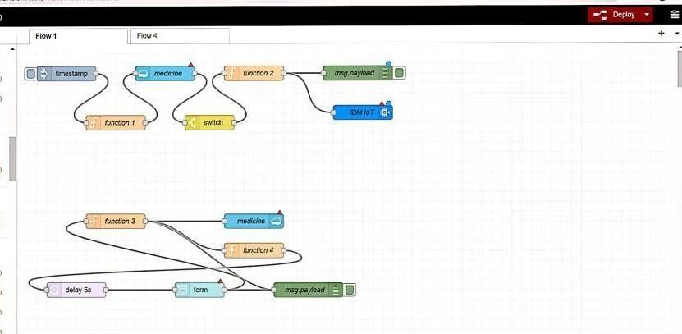

**FORM:**

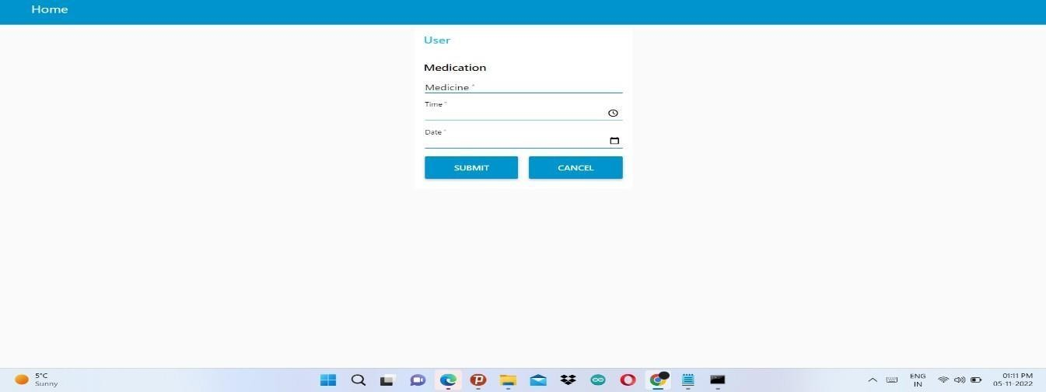

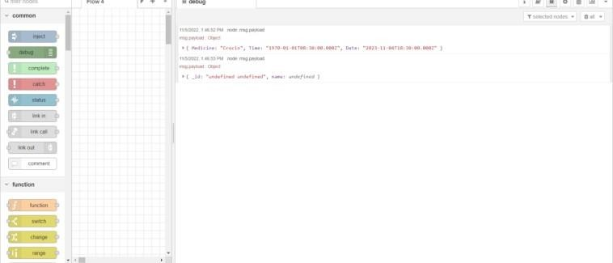

# LOG IN :

NODE RED:

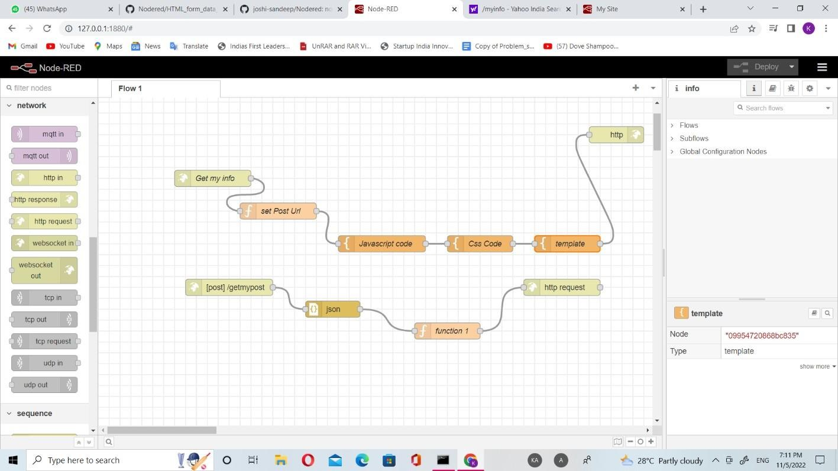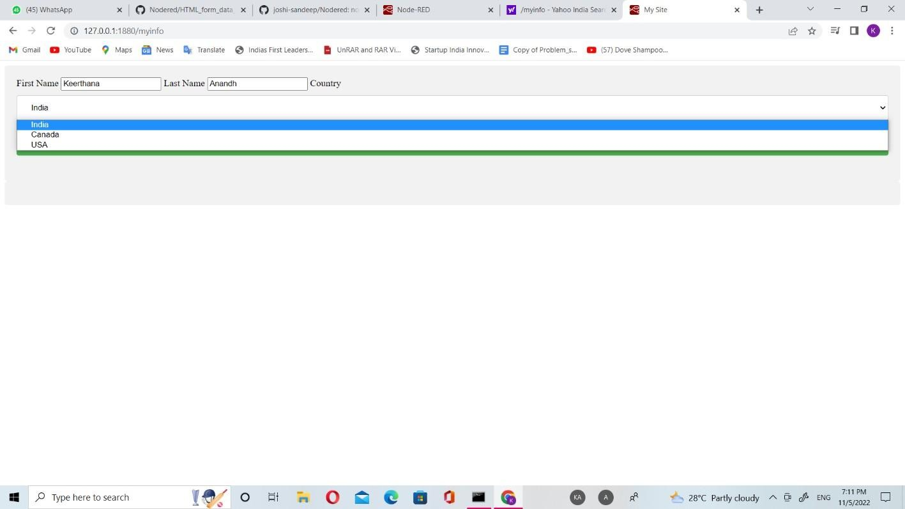

FORM: